1.Run Welcom_LoginForm

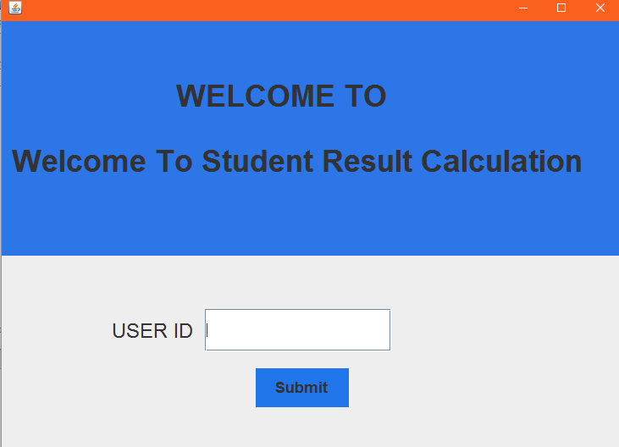

2.Put user id 2441139.

3.Fill information of student and click save. To search input info put serial num and click search button.

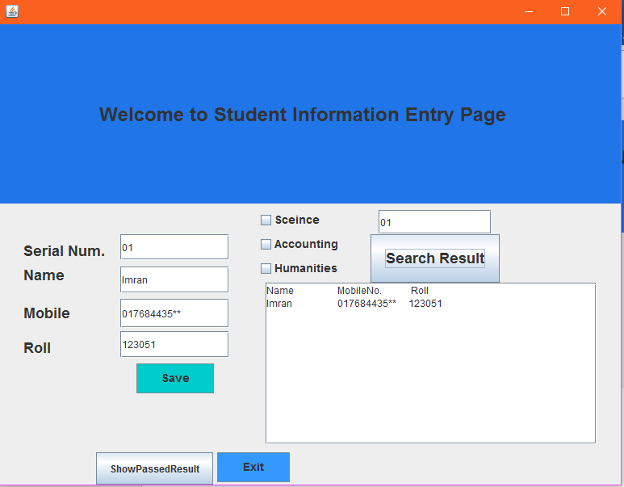

4.Input all subject number and press result button and put the serial num of individual student serial to save exact student result and then press save to store info.

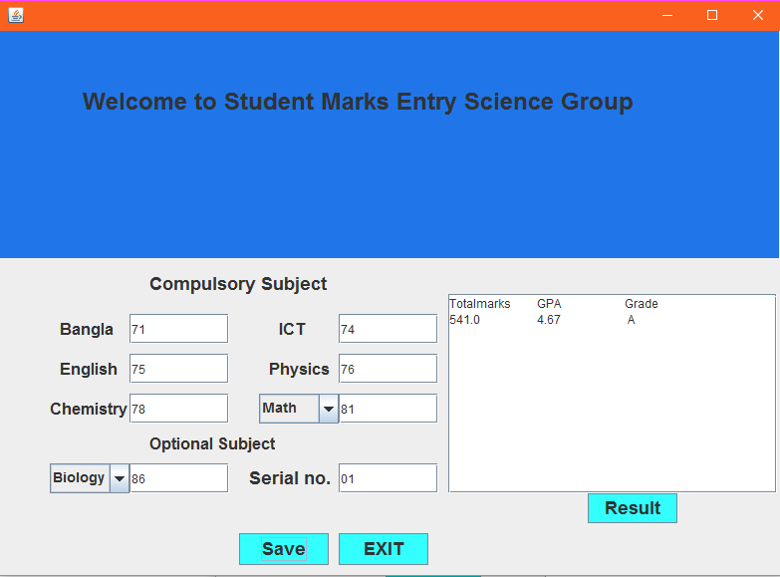

4. save and exit marks entry.

5.To get all result return to student info entry page and click showPassedresult and click show passed to passed student and to show failed student click ShowFailed.

